**Module-2: EC2 and EFS Assignment-3**

1. **Created 3 different EC2 instances of Ubuntu, Amazon Linux and Redhat**

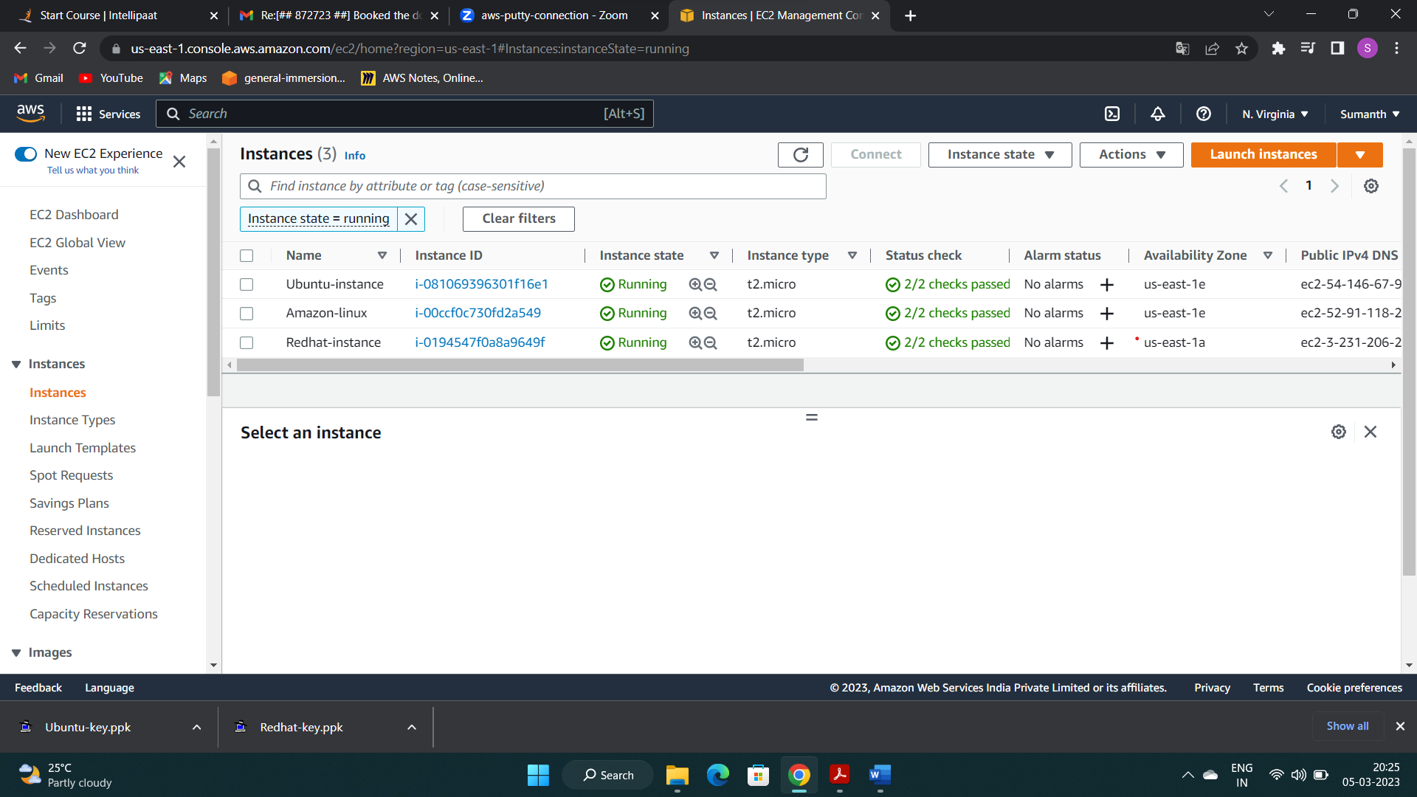

1. **Created an EFS**

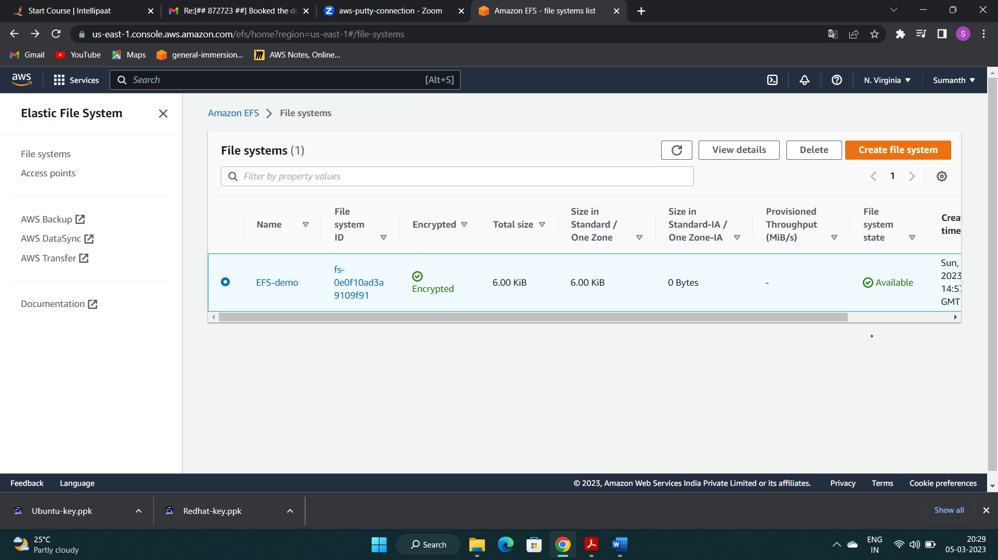

1. **Connected my EFS to all the instances by installing NFS utils**

